B.Sc. Thesis Proposal
Bangladesh Army International
University of Science and technology (BAIUST) Date: 02/10/2019

Author: | Pritilata Biswas  Sumaia Afrin Prity  Parvez Abedin Siddique | Supervisor: | Arifa Islam Champa
E-mail: | pritilata.biswas66@gmail.com  sumaiaafrin57@gmail.com  emonabedin95@gmail.com | E-mail: | ruetarifa23.12@gmail.com
Phone: | +8801923388240  +8801816540626  +8801837757975 | Phone: | +8801789544979

Proposed Topic:
Analysis of connected component for Bengali Character recognition.

Introduction
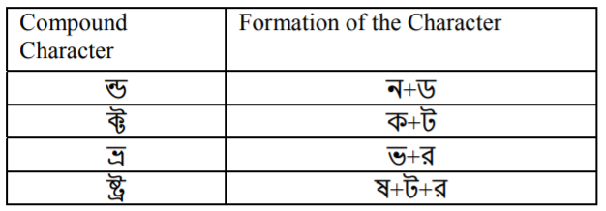
Segmentation of Bangla handwritten text is the pre-process of handwritten text. The bengali script is also used for representing other language like Meithei and Bishnupriya Manipuri, and there is time when it used to write Sanskrit within Bengal [1]. Most of the Bengali characters are topologically connected [2]. They can be easily classified using this connectedness property. This classifying or segmentation of Bengali character is the most challenging task in making a Bengali Optical Character Recognition (OCR). In Bengali there is a combination of basic, modified and compound characters. The combination of characters can be more than 300. Here, Bengali character segmentation is the most challenging task. So, we need some robust techniques that can classify these compound characters.

Table 1: Some compound characters in Bengali script [2].
As we know Bengali script characters are connected with a Matra line, so the characters can be easily recognized by the connected component analysis [2]. In this paper our main contribution is to improvise the method of analyzing connected component using some common image processing operations.

Motivation for research
In this 21st century of digital generation, OCR is one the most important technique to interface between human and machines. OCR of printed text has already achieved a huge success. ABBYY is one of the major examples of most fine reader that is commercially available [3]. A little works has been done on Bengali Handwritten character recognition [9–12]. Now, an efficient Bangla OCR system is important to be developed. Many researchers have already developed many methods of segmentation of Bengali script.
Chaudhuri et al [9] first proposed an OCR system using HPP and VPP and headline removal technique they segmented the documents into lines, words, and characters. Mahmud et al [10] first proposed an that supports multi font characters. Mahmud et al [11] used Depth First Search (DFS) algorithm for overlapped character segmentation. Hasan et al [12] proposed a hamming network for Segmentation. All of these method, they divide the words into three regions (matra line, upper zone, lower zone). For dividing them into regions one of the best approaches is to detect the Matra line and remove them. But removing them incurs some major problems in most of the characters as they are incomplete without their Matra line. So, in this paper we proposed a method that may counter this problem.

Objective
- To enhance Bengali connected component analysis
- To improvise Profile Projection with Closing operation.
- Implement Closing for Profile Projection with Dilation and Erosion.
- Comparative analysis between existing and proposed method.

Background study
Zahan at el [2] the following step by step process is proposed that is mainly based on the segmentation process.
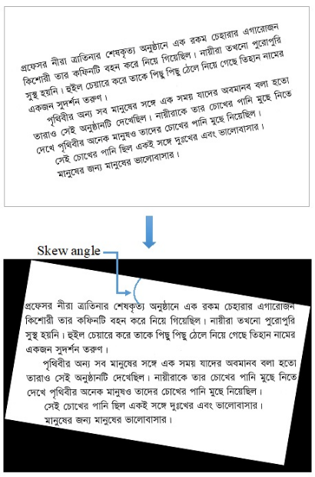
- Processing: In this step a general image is taken as input at minimum resolution of 100 dpi and maximum resolution of 300 dpi. Here the image is also checked for skew angle [4].
Figure 2: skewed Bangla printed text (at the top) and corrected skew (at the bottom) [2].
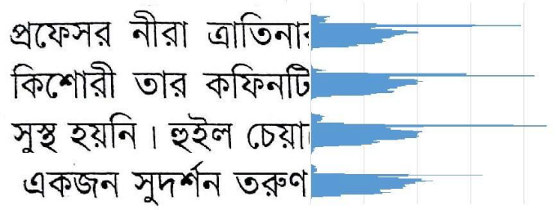
- Line Segmentation: The lines are segmented using horizontal projection profile by finding the horizontal pixel gap.
Figure 3: Line segmentation process [2].
- Word Segmentation: The words are segmented using vertical projection profile by finding the vertical pixel gap.
Figure 4: Word Segmentation [2].
- Character segmentation: The characters are segmented by Matra line detection.
Figure 5: Segmented Characters [2].
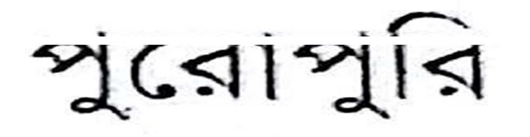
Matra line detection: The overall accuracy is depending on this particular operation. It is done by horizontal profile projection [4].
figure 6: disconnected characters after Matra line detection [2].
There is a big drawback in this method that is, if we remove Matra line some character like গ, ণ, শ will changed [2].

Figure 7: Characters split into two parts [2].



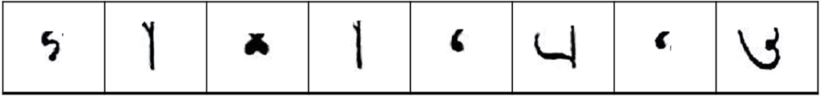
Erosion and Dilation: The most basic morphological operations are dilation and erosion. Dilation adds pixels to the boundaries of objects in an image, while erosion removes pixels on object boundaries.
(a) (b) (c)
Figure 8: (a) input image, (b) after erosion, (c) after dilation [6].


Opening and closing: Opening and closing are two important operations of morphology. They are both derived from erosion and dilation. Like those operations they are normally applied to binary images, although there are also gray level versions. The basic effect of an opening is that it tends to remove some of the foreground pixels from the edges of regions of foreground pixels. However, it is less destructive than erosion in general. As with other morphological operators, the exact operation is determined by a structuring element. The effect of the operation is to preserve foreground regions that have a similar shape to this structuring element, or that can completely contain the structuring element, while eliminating all other regions of foreground pixels.
Figure 9: opening [6]. Figure 10: closing [7].

Working Hypothesis
A typical OCR system consists of preprocessing, segmentation, recognition and post-processing parts. In this paper we mainly focused on the segmentation process which is the back bone of the recognition phase.
At first the input image will be converted into grayscale image using grayscale filter and using bilateral filter we will remove the noise in the input image. Then using bit plane slicing the input image will be binarized and will be converted into two-tone image. Some input image may be skewed by a few degrees. For skew correction we will use the skew angle technique [4].
In Bengali script, lines are almost of the same height. There is a horizontal gap between two lines. We will detect those gapes by horizontal projection profile (HPP). Vertical projection profile (VPP) will be used in word segmentation from extracted lines. In this process the number of black pixels in each column will be calculated. In vertical scan if no black pixel found then it will be considered as the gap between words.
Bengali words are connected through Matra line. By removing them, characters get topologically disconnected. Then using the connected component method, individual components of a word can be separated. Now we will apply erosion and dilation to remove the problems that will occur from the removal of Matra line. Finally, we will analyze the connected component (each character) how close they are.

Methodology
This is our proposed methodology for the new process:
Step 1: Input Processing
- Apply grayscale filter
- Apply bilateral filter
- Apply Bit plan slicing
- Skew angle correction
Step 2: line segmentation
- Apply HPP
Input image
1.Matra line detection
Steps 4: Character segmentation
Steps 3: Word segmentation
- Apply VPP

Apply
Dilation + Closing
Apply HPP
Analyze connected component

Figure 11: The proposed methodology.

Outline
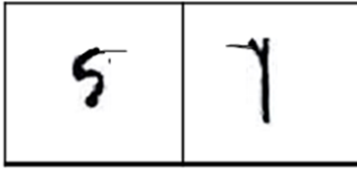
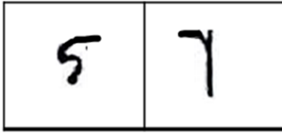
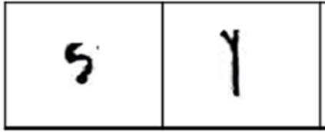

(a) (b) (c)
Figure 12: (a) Current output which occurs problem [1],
(b) After closing expected output [6], (c) Dilation on (b) [6]

Reference
- https://en.wikipedia.org/wiki/Bengali_alphabet
- T. Zahan, M.R. Selim, M.S. Rahman, M.Z. Iqbal, (2018). “Connected Component Analysis Based Two Zone Approach for Bangla Character Segmentation.” 1-4. 10.1109/ICBSLP.2018.8554684.
- https://www.abbyy.com/ . Last accessed 07 Dec 2016
- M. A. Obaida, T. K. Roy, M. A. Horaira and M. J. Hossain, “Skew Correction Function of OCR: Stroke-Whitespace based Algorithmic Approach,” International Journal of Computer Applications 28(8):7-12, August 2011.
- S. S. Goswami, “Identification of Matra Region and Overlapping Characters for OCR of Printed Bengali Scripts,” Intelligent Computing and Information Science, Volume 135 of the series Communications in Computer and Information Science, 2011, pp. 606-612
- https://docs.opencv.org/2.4/doc/tutorials/imgproc/erosion_dilatation/erosion_dilatation.html
- https://homepages.inf.ed.ac.uk/rbf/HIPR2/open.htm
- https://homepages.inf.ed.ac.uk/rbf/HIPR2/close.htm
- B. B. Chaudhuri and U. Pal, “A Complete Printed Bangla OCR System,” Pattern Recognition, Vol. 31, No. 5, pp. 531—549, 1998.
- J. U. Mahmud, M. F. Raihan and C. M. Rahman, “A complete OCR system for continuous Bengali characters,” In: Proceedings of the TENCON, 1372–1376, 2003.
- S. M. M. Mahmud, N. Shahrier, A.S.M D. Hossain, M. T. M. Chowdhury, and M.A. Sattar, “An Efficient Segmentation Scheme for the Recognition of Printed Bangla characters,” Proceedings of ICCIT, pp 283-286, 2003.
- M. A. M. Hasan, M. A. Alim, and M. W. Islam “A New Approach to Bangla Text Extraction and Recognition from Textual Image”, Proceedings of ICCIT, 2005.

Supervisor Signature

